**Adder - Coronavirus Proposal**

[**bit.ly/stop-coronavirus**](http://bit.ly/stop-coronavirus)

**Background**

Adder is in the business of knowing when people and places intersect. We collect position data from 50 million smartphones every day, all in the United States. This data comes in the form of 3.5 billion sets of GPS coordinates.   
  
Adder uses this location and positioning data to attribute visits, like when someone passes a billboard and then goes to the place being advertised. Or when someone that goes to an event hosted at a city park.

Or perhaps, in this case, when a person comes into contact with a COVID-19 carrier.

----------------------------

**Context**

As of this writing, COVID-19 “Coronavirus”, just crossed the threshold of 1,000 confirmed victims in the U.S., indicating a potential to spread very quickly. Data reported from health officials worldwide reveals a substantial mortality rate among the infected.   
  
With confirmed cases and public concern growing, steps must be taken to track and contain the spread of Coronavirus -- otherwise we face widespread illness and catastrophic loss of life.  
  
Adder has been preparing for the launch of it’s traffic analytics platform on April 1, 2020. Our engineers built tools designed to process movement and contextual location data at a meta scale. We are a small team of developers and geospatial engineers that want to solve problems and change the world with our technology.  
  
This is a real opportunity to do precisely that.  
  
With a few customizations to our smartphone vehicle tracking apps, web portal, and our ad exposure algorithms, **we can track the spread of this virus from person to person** to help the CDC and other public governing bodies understand how to address this growing problem.   
  
We need public support to do this, as we would need to have everyone possible contribute to the reporting process. The more people that contribute to fighting COVID-19 by downloading our virus tracking/reporting app would help health officials figure out who they crossed paths with. If anyone came into contact with a known carrier of the Coronavirus, we’re able to let a potential case know as soon as that carrier is positively identified in our database.

**Use Case 1 - Measure POIs based on known carrier movement**

CDC diagnosed patients enter in a code from CDC and then allows the Adder App to share their phones identifier for advertising. This information then allows Adder to identify the location of the patient's phone for the last month. The places the virus has been can then be shared on a map for analysis, allowing test kits and medical resources to be provisioned efficiently, and for the public to see if they are “locationally at risk.”

With additional funding - the 50 million cell phones being tracked by Adder can be increased to a 90% of more of the smartphone’s in the US, helping measure more of the population.

While our current use cases for advertising did not require more than a 25% sample set, this mission critical use case demonstrates a clear need to get as much coverage as possible, and with the proper funding could be purchased and added to the Adder Location Analysis Platform.

**Benefits:** Focus on areas where the virus is spreading to focus limited response resources.

**Use Case 2 - Opt-in location analysis to measure exposure using Adder’s historical data.**

Members of the public can download the app or visit our website and view and “opt in” to see if their path for the last month intersected any of the “high risk” places that the virus has been. We will then be able to create additional information on the number of people in contact with the virus that DID or DID NOT also become infected.

**Benefits**: Public communications and assurance, identify at risk members of the public, limit testing of low risk members of the public by providing data that shows they were not near virus zones or at risk.

**Use Case 3 - Opt-in location analysis to measure exposure using a tracker app.**

The Adder Coronavirus tracker smartphone app can help the general public track their locations, warn them when they are coming in contact with a potential virus zone, and allow their location data to be examined if they are diagnosed.

**Benefits**: All of the benefits listed above, but with more data to work with, reported in real-time. This would cut down substantially on response times to take action with our exposure data.

**Methodologies**

Today, Adder has a geospatial analytics engine, which is designed to show advertisers the number of people that pass their billboards using anonymized location data from 50 million Americans. This technology is being adapted to measure exposure to the virus, instead of an advertisement.

A few modifications will be needed to see who passes within 6' of a person carrying Coronavirus, but it’s possible to do so if we can get public buy-in on a tracker that **will** help mitigate the spread of Covid-19.

**Method 1 - Monitor Areas Carriers have Transited Through**

1 - Identify known carriers locations

* Sources
  + CDC data (can use location of known outbreak)
  + News stories about specific use cases

2- Monitor population movement data through POIs visited by known carriers

* Count number of people moving through tagged areas
  + Tag these people’s anonymized userID with scores describing their likelihood of crossing paths w/carriers

3 - Monitor congregation points for outbreaks

* If hypotheses are correct, we should see patterns emerge

4 - Interpret any patterns, by hand if necessary

5 - Monitor hospital or other relevant POI polygons, match any people that were in a congregation point/came into contact w/known carriers.

6 - Turn the ‘potentially exposed’ audience data over to CDC for review and use.

**Method 2 - Track Exposure to Carriers on an Individual Level w/Historic Data**

1 - Identify known carriers in Adder location database

* Methods
  + Self-Reporting
    - AD_ID
    - IP Address
  + CDC data (would need collaboration)
    - AD_ID
    - IP Address

2 - Modify Adder Impressions Algorithm to determine exposure to confirmed cases (CDC radius = 6’)

* Exposure Radius Modifications
  + Decrease exposure radius max from 50’ > 6’
  + Decrease exposure radius min from 100’ > 10’
* Exposure Time Modifications
  + Increase exposure time max from 1 minute > 60 minutes
  + Increase exposure time min from 3 seconds > 60 seconds

3 - Run Adder Algorithms and process list of contacts exposed to confirmed cases

* Score exposure based on time
* Score exposure based on distance

4 - Turn the ‘potentially exposed’ audience data over to CDC for review and use.

* GeoJSON or BSON
* CSV (?)
* Mapped in web GUI

**Method 3 - Track Exposure to Carriers on an Individual Level w/Real Time Data**

**Method 4 - Track Exposure across the US using E911 Cell Position Data**

**Content Available:**

Maps

CDC Data: <https://adder.io/covid-map>

Diagrams

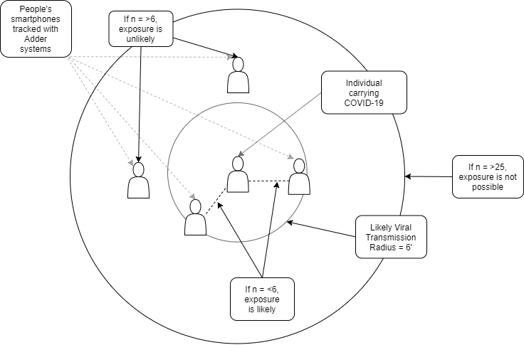

Github Repo

<https://github.com/AdderMobileTechnologies/stop-coronavirus>

**Privacy & Data Security**

Adder already works with HIPAA compliant providers for data processing and storage, and meeting compliance completely would not be difficult with our current data handling standards in place already.